IARS

IARS

Club Call VK2AMW
VOLUME 06/03 ISSUED June, 2005. PRINTED BI MONTHLY
PRICELESS.
Meetings held second Tuesday of each month (except January).
S.E.S Building Montague Street, Nth Wollongong. Starting at 7:30pm.
The Propagator is the Official newsletter of
ILLAWARRA AMATEUR RADIO SOCIETY INC.
PO Box 1838 WOLLONGONG 2500.
WEB Page - www.iars.org.au
E-MAIL - secretary@iars.org.au
Editor- Maeva Bennett VK2HUG

Editorial

Welcome to my second edition of the Propagator. This will be a bumper issue as a lot will be going on in the next month – the 2005 Annual General Meeting on the 9th August, the 2006 membership renewal and the 2005 Lighthouse Weekend all happen this month. I hope all received their AGM notifications either by email or via Australia post, from the Secretary. Further copies or if it did not reach you, it are available on the IARS webpage.

This issue is early as our webmaster is going on holidays and it necessitated that this issue was to be done in a hurry. Any errors or omissions, I am sorry but I was working in a restricted time allocation.

Please note that our Webmaster, Michael, has removed from www.iars.org,au/ the Club webpage, all copies of the Propagator before 2005. Michael had to do this as the web page was getting too big and approaching its limits. He has put all past issues into an archive, so if anyone needs a back copy, just contact him or the Secretary to arrange to send to you the issue you want.

I hope you find something in this issue that interests you and that you continue to enjoy your club and your hobby of amateur radio.

In conclusion, just a warning. A ham in the US was pulled over by the police, a NC man who equipped his Chevy Caprice Classic with ham antennas. He is now *charged* with driving a car that resembles a law enforcement vehicle. Apparently that is a law in NC.

Pity, the aerials on my car always makes it easier for me to find in supermarket parking areas.

Maeva Bennett

The Illawarra Amateur Radio Society Inc Executive and Committee

Acting President: Rob McKnight VK2MT mcknight@winnsw.com.au 0408 480630
Secretary: John Bennett VK2AAL vk2aal@comcen.com.au ph: 4297 6065
Treasurer: John Lawer VK2KEJ ph: 4228 9856

Committee.
Geoff Howell VK2HIC (Public Relations and Publicity) vk2hic@nsw.chariot.net.au
Boris Rewak VK2JJJ boza@ihug.com.au
Peter Reid VK2HPR vk2hpr@1earth.net
Ned Macintosh VK2AGV criticalmass@hotkey.net.au
Daniel Brem VK2TAU dan@knowmore.com.au Ph 0419 288682

Fund Raising Committee. Geoff Howell VK2HIC, Peter Reid VK2HPR and Jack Desceso VK2XGD
Editor. Maeva Bennett VK2HUG vk2aal@comcen.com.au
Publicity Officer. Geoff Howell VK2HIC
Membership secretary. John Bennett VK2AAL vk2aal@comcen.com.au ph: 4297 6065
Repeater Committee. Rob VK2MT, John VK2AAL
Canteen. Peter Reid VK2HPR.
Web Master. Michael Eckardt VK2GNV, with help from Daniel VK2TAU.

Homebrew Night

Our next meeting in August will also be a time to discuss Homebrew. Please bring your homebrew to the meeting to show it off and inspire other hams that things can still be homemade at a much reduced cost and be specifically purpose built to your own specifications.

Homebrew will be after the AGM.
Alfred Traeger The Pedal Radio Man

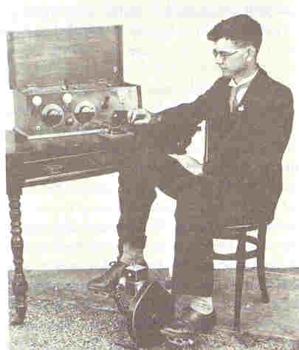
Have you ever looked at the back of the Australian $20.00 note issued on the 31 October 1994? If you have you will notice along with Dr Flynn, a flying doctor air craft, a medical diagram and a camel, and there is a pedal radio?

Australia is a unique country in which to live, it is extremely diverse, expansive and harsh to those who live here. The uniqueness of our country gave rise to the Australian that believed that “necessity is the mother of invention”.

Alfred Traeger (1895-1980) was such a person. Alfred Traeger was born in Glenlee, Victoria in 1895 and grew up on a farm at Balaklava in South Australia, Young Alfred always had an interest in electronics and at age 12 had rigged up his own telephone receiver-transmitter between a shed and the farmhouse, using mostly odds and ends found around the farm. In 1907 the quiet Australian farm boy astonished his family by building a telephone between the homestead and a machinery barn 50 yards away. He had no commercial equipment -- the magnets were made from pitch fork prongs, the diaphragms from tobacco tin lids, and the charcoal for carbon granules came from the kitchen stove. The ubiquitous farm fencing wire was also called into service. Before he was 20, Traeger had put together a transmitter, 1914 style, was sending Morse at 20 words a minute, and was working towards his amateur license.
This interest developed and he received a scholarship to the School of Mines where he qualified as an electrical engineer on ammeters and generators-while still dabbling in radio. His knowledge of radio attracted John Flynn 'Flynn of the Inland', who asked him to accompany him to Alice Springs to conduct some experiments and develop a cheap, efficient radio to connect people of the outback with a central station.
Traeger adapted a WW1 idea of using pedals to generate electricity, to create a transmitter-receiver, and in 1929 launched the Traeger Pedal Radio at a then cost of £33 ($66).

Together Flynn and Traeger set up the first base station at Alice Springs -- the country's geographical center. A couple of outstations soon followed, and in 1926, 2-way radio became a reality in one of the most remote places on earth. But Alf Traeger quickly saw the major obstacle to a wider network -- the awkward, heavy duty, glass, copper oxide Edison batteries -- as well as the need for a reliable high-power voltage supply to the local transmitter. A simple, durable alternative was essential for ordinary outstation use.
In 1927, Traeger built a hand-powered generator. It was transported from Longreach to Cloncurry in the vast emptiness of western Queens-land. Flynn turned the generator while Alf worked the Morse key. The rig performed beyond expectations. Excitement for a wider bush network mounted, with Cloncurry the proposed site for a base station. All systems were go, until the fatal flaw in the hand-generated outfit became apparent. A lone operator could not generate power and send Morse simultaneously, and most homestead emergencies involved a lone woman.
Traeger, now a man possessed, worked dawn to dusk in his Adelaide workshop to solve this problem. But, at Flynn's request, he first remodeled the transmitter and receiver into a compact, easy-to-operate "baby set,". He then returned his attention to the high voltage supply problems. His brother Jack remembered the moment in August 1928 when Alf, eating lunch in the workshop, suddenly stood up and said, "I'm going to buy bicycle pedals."
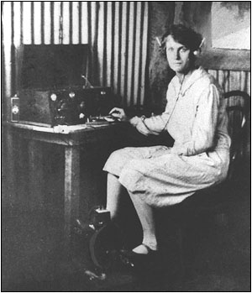
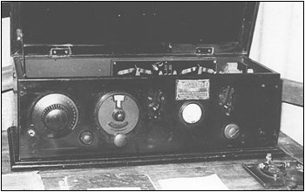
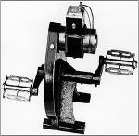

On the 19 June 1929, the world of communication took on a whole new dimension when the first pedal radio message was sent from Augustus Downs, a remote station in Queensland's far north west.

The words “Greeting by wireless service from Augustus Downs first station installed.
Manager, family and station deeply appreciate service rendered” said by Mrs Gertrude Rothery, marked a momentous occasion in world communication history.

By 1933 these sets were extensively used and new models were frequently launched. Traeger then overcame the problem of outback people having to use morse code by designing a morse keyboard, similar to a typewriter, which sent out the correct signal at the touch of a key. By 1939 he had developed a set which used vibrator units instead of pedals, however, as recently as 1962, the Traeger Radio Company was exporting pedal sets to Nigeria.
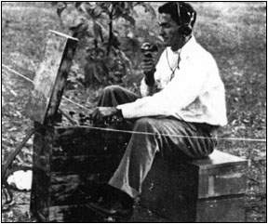
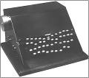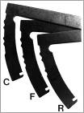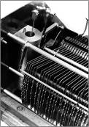
The Traeger portable set of the mid-1930s, was built in identical stacked cases with receiver and transmitter mounted up top, and pedal generator and batteries below.
The receiver tunes from the broadcast band to the higher frequencies of the bush network. It uses a Type 32 tube as RF amplifier, a second Type 32 as regenerative detector, a Type 30 for audio driver, and a transformer-coupled Type 49 for output. Receiver power comes from 90v/22.5v dry B batteries, 9v bias for output grid. Two large No. 6 (1.5v) cells in series supply the 2v heaters.
The transmitter uses a Type 33 as Miller-type oscillator, keyed directly for CW signals. For telephony, a Type 30 is used as microphone preamp, and is transformer-coupled through a 19 double triode to the Type 33 oscillator/final. The high-power plate supply for the Type 33 comes from the pedal generator.
Transmitter coils are wound on a plug-in former, which also carries the open slab crystal in a plated cylinder along with tuning capacitor and tuning lamp. The set uses a random length aerial, plus counterpoise. Power output is around 1.5 watts into the aerial.
The 2-way network became the heartbeat of outback life. In conjunction with the Flying Doctor Service, it turned Flynn's concept of a mantle of safety into an everyday reality. It made possible the legendary "School of the Air," now an institution for bush children across the country. Best of all, the ever-changing equipment in the corner of living room or kitchen lifted the final, ever-present burden of the bush pioneers -- the blight of loneliness

Traeger died of cancer at the age of 85 in 1980 quietly as he had lived his life. By this time, 6000 transceivers on the Flying Doctor Service heard the sad news “Traeger is dead”.

The proper technical Stuff:
The birth of pedal radio
With the design criteria sorted out, Flynn gave Traeger the job of developing a suitable transmitter/receiver under the watchful eye of Harry Kauper (Traeger's mentor), who contributed his considerable skills to the design. After many experiments, Traeger built the first pedal radio and unveiled it to Flynn in November 1928. This was a magnificent achievement, as it was the first portable high-frequency (HF) transmitter/receiver in the world that could be used by non-technical people.
According to its operating licence, the transmitter was crystal-locked on 2230 kHz. It used a B205 valve which was operated in class 'C' mode as a Morse code (CW) transmitter. Now the efficiency of small battery valves was quite low in class 'C', so an input of about 4 W gave just 1.5 W of output power - ie, it was only 40% efficient.
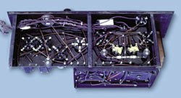
An under chassis view of the 1930 pedal radio. The transmitters used A615 valves (or A415s) and had an RF output power of just 1.5 W.
The low-tension 'A' battery supply came from two No.6 cells in series, while the high-tension 'B' supply was nominally 180 V but depended on how quickly the operator pedalled the generator (hence the name pedal radio) which supplied this power.
The transmitter was coupled to a quarter-wave wire aerial and a tuned counterpoise system. This proved to be an extremely effective antenna system, which it needed to be, considering the low transmitter power and the long distances over which the equipment was required to operate. In fact, this type of system was used up until relatively recent times.
The receiver was a simple 2-valve unit. It consisted of a regenerative detector and a transformer-coupled audio output stage which fed a pair of headphones. It tuned the broadcast band and one shortwave band, which included 2230 kHz.
The valves used were two A141 space charge tetrodes which required 1.5 V ('A') for the filaments and 9 V ('B') - from two 4.5 V bias batteries - for the high tension. The very low voltage on the 'B' supply was sufficient for the A141 valves, which were designed to operate effectively on voltages from 2-20 V.
Kauper selected the A141 valves because they drew very little current at low voltages. High voltage dry batteries of the era deteriorated very quickly in sub-tropical environments where these sets were to operate, such as Cloncurry in Queensland.
Six such sets were installed during 1929 within a radius of 600 km of the Cloncurry base. They quickly proved their worth when it came to saving lives, by summoning aircraft to carry patients to the hospital at Cloncurry.
Base transmitter
The Cloncurry base transmitter was much more powerful than the pedal radios, having an output power of 50 W on (AM) voice. Of course, fixed base transmitters of reasonable power drew considerably more electrical power than a pedal radio transmitter. However, this wasn't a problem in this case, as a 32 V lighting plant had been installed at Cloncurry to power the base station (despite the expense).
The base station receivers were also more elaborate than the pedal radio receivers, mainly because they had to be more sensitive.
Teething problems
Despite quickly proving their worth, practical experience with the new radios during the first few months also revealed some shortcomings. In particular, the sets were not always able to achieve reliable communications. To achieve that goal, it was evident that a frequency near 10 MHz was needed in addition to 2 MHz.
It was a case of going back to the drawing board and making the necessary improvements so that the pedal radios would be effective. Although the pedal generator had proved quite satisfactory, the receiver lacked gain and stability and it seems that the transmitter valve may not have been rugged enough to stand the physical abuse of being bumped around in the outback.
As a result, these first six sets were scrapped over a period of time and their parts used in later improved sets, which is why there are no examples of the original sets in existence. However, there are two photographs which do show what they looked like.
The 1930 pedal radio
Harry Kauper decided to move to Melbourne in 1930, which meant that he was now able to provide only limited assistance to Alfred Traeger. Left largely to his own devices, Traeger used the best design aspects of the original sets and worked on methods of overcoming the weaknesses.
The replacement sets were built into a heavy metal case (to thwart termites) and the original single transmitter became two transmitters - one on a frequency of 2020 kHz (night frequency) and the other on 8630 kHz (day frequency). Exactly when these frequencies were issued is uncertain but it was definitely by 1931.
Traeger reasoned that by having two transmitters, communications with Cloncurry could be achieved either on the night frequency or the day frequency, even if one broke down. The transmitter design remained essentially the same as before, except the valves used were now A615s (or even A415s), which required four or five No.6 cells in series to power the filaments. The radio frequency (RF) output power remained at about 1.5 W.
The antenna design also remained much the same as for the original set but it was now expected to operate on the two frequencies. As a result, two separate counterpoises were used in these units.
Initially, they were tuned in the same way as the original pedal radios, by laboriously adjusting the length of each counterpoise. Later on, they were modified so that the electrical length (and hence the tuning) of each counterpoise could be adjusted within the set itself.
No meters were used in the transmitters to indicate the correct tuning. Instead, tuning was carried out by watching a small pea lamp and adjusting the transmitter and counterpoise controls for maximum lamp brightness.
It was said that if you got a glimmer out of the pea lamp, you had succeeded in tuning the transmitter!
The receiver, although also basically the same as the original, now boasted three conventional A109 triode valves. There was a regenerative detector and two transformer-coupled audio stages, with the output stage feeding a pair of headphones or, if the signals were really strong, a loudspeaker.
The receiver was able to tune the broadcast band and up to around 10 MHz using plug-in coils. It was a much better performer than the original but now required a 45 V HT battery in lieu of the 9 V HT battery used in the original receiver.

References:
McKay, Fred. Traeger, The Pedal Radio Man. Moorooka, Australia: Boolarong Press, 1995.
Richard Begbie Columnist for the Canberra Times
Silicon Chip magazine January 2005 issue.


Call in a see Jack VK2XGD
I have been told there are special discounts for IARS members
Not to mention, specials just for us……..Ed.

2005 COMMITTEE REPORT

Unless you have been out of the country, most of you would be aware of the situation that has existed between the IARS Committee & Ted VK2ARA over the past 6 months regarding Affiliation with the WIA & also the taking-up of their Public Liability Insurance Policy.

Let me state from the outset that Ted is entitled to his own beliefs and agendas, as does anyone else.

However, the facts of the matter are, we wouldn’t be in this unfortunate state of affairs if Ted hadn’t first acted against official Committee decisions in applying for something we didn’t want or need (ie: WIA Affiliation & Insurance) & then when this first situation was resolved by the Committee, he then felt obligated to openly & publicly challenge the Committee’s decisions by calling for a Special General Meeting to vote on re-applying for Affiliation & Insurance.

Your Committee was quite taken back by Ted’s insistent allegations & assertions that they were ignoring facts & were not acting in the best interests of the Club. All elected Committee members take their positions VERY seriously & Ted’s claims were seen by all as an attack on their integrity & honest actions in running the business affairs of the IARS.

Despite these ongoing verbal & written assertions, apart from seeking direction from Members at the March General Meeting, the Committee as a whole have kept quiet & resisted replying so as not exasperate the situation & allowing it to degenerate into a “tit for tat” session. This decision may however have worked against us as we now have a situation where many Members now question what the Committee has done to resolve the problem & reduce the increasing divisiveness inside our Club. (This was witnessed at the May Meeting.) This apparent lack of knowledge by the IARS Members is the reason for the writing of this Committee Report.

Here are the facts as we know them, you be the judge:

- Early January, Ted intercepted & opened official mail addressed to the IARS Secretary

- Contrary to Committee decision & without authorization, Ted filled-out a WIA Affiliation form

- Contrary to Committee decision & without authorization, Ted filled-out a WIA Public Liability Insurance form

- He then co-signed a cheque requested from the Treasurer for $190.58 for the WIA Insurance Policy

- Committee decision or otherwise, this was a total waste of Club funds for an extra Insurance Policy that we neither needed or wanted.

- This second policy then placed the IARS in an awkward & concerning situation where the Club could be seen to be fraudulent or in fact, perhaps be exposed to no cover with each Insurance company rejecting liability for any claims.

- By Ted’s own later admission, the signing of this cheque to an Organisation that he is also a Director, could be seen to be a conflict of interest.

- At the February Committee Meeting he defended his actions by claiming that despite him actually being a Committee person at the time himself, he did not know of the Committee’s decisions regarding WIA Affiliation & Insurance. The Committee accepted his explanation.

- When the Committee was alerted to the Insurance concerns, they discussed at length the best course of action. It was decided to consult the Members at the next meeting & seek their thoughts & direction on the situation.
- The overwhelming majority of attending Members at the March Meeting agreed with our concerns as they were presented.

- Over the following week, many e-mails were sent & received by the parties concerned.

- Ted tendered his resignation twice & confirmed his absolute resolve in another e-mail.

- The acting President repeatedly requested his reconsideration in this matter & invited his attendance at the upcoming March Committee Meeting.

- At the Committee Meeting, all parties were given a fair hearing, in fact it could be considered that Ted received more consideration than others.

- After much discussion, all attending Committee Members believed the situation had been resolved.

- A letter was later sent to Ted informing him that the Committee had decided to rescind WIA Affiliation & Insurance & that these matters will be more thoroughly investigated to gauge actual benefits for the IARS before re-applying.

- The letter also once again accepted his explanation that he did not know that he was acting contrary to Committee decision & also acknowledged his request to rescind his previous resignation requests.

- Two weeks later, despite now being more than aware of the Committee’s strong feelings on the matter of WIA Affiliation and Insurance, Ted decided to challenge these decisions by writing to all Members requesting their support for the calling of a SGM & for two motions to overturn these Committee decisions.

- One has to question his original explanation of not being aware of Committee decisions on these matters in light of this new challenging of same.

- Ted’s letter suggested that his actions in applying for Affiliation & Insurance was a united decision made by himself & John VK2KEJ. Ask John yourself how he feels about this implication & supposed involvement.

- This letter also asserted that we were turning our backs on the WIA. This was not the case, we had been strongly supporting the WIA by airing their Broadcast in preference to AR NSW’s Broadcast.

- As well, this letter asserted that the IARS now didn’t have a “representative voice”. What was not mentioned was that an Affiliated Club does not have any voting rights, as against singular Members that do.

- Further, this letter asserted that our existing Public Liability Insurance Policy via AR NSW, that we & 70 or so other Clubs had had for decades, now did not provide adequate coverage.

- Despite the Committee’s total surprise at Ted’s turnaround, the Committee as a whole made a conscious effort not to reply & exasperate the situation.

- About two weeks later, despite apparent support for his calling of a SGM, Ted decided not to go ahead with his actions.

- He included four reasons for the change of heart. Three blamed the Committee (eg: for “repeatedly ignoring factual information) & one blamed apathy of the Members in not giving a “cracker” about the situation.
- Unfortunately despite his change of heart, the damage had been done. Internal divisiveness & ill feeling inside the Club was now increasing & as well, the Propagator Editor had resigned.

Since then, your Committee has been working hard to try & repair the damage that has been created. The Club WILL survive because it is made up of good people who enjoy being part of the best damned Club in Australia!

At the upcoming AGM, you are invited to show your support for the IARS by putting your hand up to be on the Committee or Executive. You can then be part of the decision making to decide whether the WIA Affiliation & Insurance is of actual direct benefit to OUR Club.

Regards,
The IARS Committee – 25/7/05

Lighthouse Weekend
Saturday and Sunday 20th -21st August 2005

At Kiama Lighthouse

Join the fun and help to raise the public profile of our lighthouses. Many lighthouses and places of associated interest will be open to the public, and there will be special events at lighthouses all around the world.
Over the past 7 years, International Lighthouse/Lightship Weekend (ILLW) has grown to over 370 lighthouses in some 51 countries around the world participating in the event. The event is always held on the 3rd full weekend in August and it now coincides on the Sunday with International Lighthouse Day.
The lighthouses are "activated" by amateur radio operators, and the basic objective of the event is to promote public awareness of lighthouses and lightships and their need for preservation and restoration, as well as to promote amateur radio. Hams set up their gear in or next to a lighthouse / lightship, and make contact with other lighthouses.
The public is invited to participate, to learn about radio and the importance of lighthouses and their preservation.
David Downie, VK2EZD, has organized for the Kiama Lighthouse to be our Local focus for this weekend. He has put a lot of work into setting up the weekend, to ensure that it is a success. He has applied to Amateur Radio NSW for permission to use the ARNSW call sign and the event is covered by the ARNSW insurance policy and it is an ARNSW authorized event.
David will also be demonstrating his “Balloon Aerial” during the weekend.
The station will be operating over both Saturday and Sunday, so please try to spend some time down at Kiama.
If further information is needed, please contact David.

Help Wanted Can you help out?

Shoalhaven Rovers are looking for someone to be our Radio operator for the Shoalhaven's JOTA for the local scouts and guides on 15th and 16th October this year. If you have anyone who is available please contact either by email lane_alice@shoalhaven.net.au or on 44235128.

Danielle Lane
Crew Leader
Shoalhaven Rover Crew

The 2005 Annual General Meeting and Membership Renewals

Annual General Meeting Tuesday, 9th at 7.30 pm

SES Headquarters

Montague Street, North Wollongong

By now hopefully all members should have received from the Secretary, nomination forms and a membership renewal notice. If you have not, please contact John Bennett VK2AAL.

The Meeting will be the last for the 2005 Committee, so annual reports for our Club will be presented and elections held for the 2006 Committee.

It is your Club, and you have a voice, who will hold office in 2006, how the Club is to be operated and directed in the future year. Your voice is important to guide the Club and to make it a valuable part of your hobby, your input is vital.

If you wish to nominate or nominate someone else to the Committee, please forward the Nomination form to the Secretary, John Bennett VK2AAL via Australia Post to the Club mailbox (PO box 1828 Wollongong NSW 2500) or by email secretry@iars.org.au by the 2nd of August, 2005.

Once again, membership renewal is also due. Membership fees are $25.00 for ordinary membership and $20.00 for those that hold concession cards. Please use the renewal form when renewing your membership.

You will notice a few new items on this list. They are not mandatory but for Club information only. The questions on Club memberships relate to information required by the Club for affiliation both with the WIA National and the ARNSW and insurance issues.

The other question, years licence held, relate to a new idea the Committee has, that is to recognise with Certificates of Participation in both Amateur Radio and membership of the Illawarra Amateur Radio Society that will be introduced in 2006.

Be aware of new car-jacking scheme
Please pass this along to anyone you know and care about Beware - Warning from NRMA Be aware of new car-jacking scheme
You walk across the car park, unlock your car and get inside. Then you lock all your doors, start the engine and shift into REVERSE, and you look into the rear-view mirror to back out of your parking space and you notice a piece of paper stuck to the middle of the rear window. So, you shift the gear stick back into PARK, unlock your doors and jump out off your car to remove that paper (or whatever it is) that is obstructing your view.

When you reach the back of your car, that is when the car-jackers appear out of nowhere, jump into your car and takeoff!!
Your engine was running, you would have left your purse in the car and they practically mow you down as they speed off in your car.
BE AWARE OF THIS NEW SCHEME THAT IS NOW BEING USED IN SYDNEY Just
drive away and remove the paper that is stuck to your window later,

Copy of submission sent to the ACA from the Secretary regarding PBL

-Illawarra Amateur Radio Society (Inc)
PO BOX 1838 WOLLONGONG NSW 2500
www.iars.org.au
Email secretary@iars.org.au

27 June 2005

Manager BPL Project Team
Australian Communications Authority
PO BOX 78
BELCONNEN ACT 2616

Email pbl.issues@aca.gov.au

General Issues re Broadband over Powerlines.

After reading your Discussion paper and bringing to the attention of our members it was decided to send a submission on behalf of the Illawarra Amateur Radio Society.

It would appear that by allowing Broadband over Powerlines (BPL) the Australian Communications Authority (ACA) can not guarantee that the interference from the system will not degrade, rather make communication in the 1.7 – 30 MHz useless to all who use it, including emergency services. The ACA is not protecting the people with licences to operate on these frequencies.

Power lines and population in Australia seem to be mostly on the coastal areas, they are subject to salt spray and arcing so the power levels required to force broadband over these lines would be at such a level that interference in Australia may be transmitted worldwide by skip ie pollute the whole world with HF interference.

A solution to the problem would be to use the money required to set up BPL to fit a fibre optic cable to each business or house. This may seem to be a more expensive solution but it would be a move to the future with the capacity of many hundreds of times, the proposed system. In the long term, it could be less expensive for the operator if the system was a shared system and could be used for reading meters, cable entertainment, telephone and very fast internet and many other communications.

All of this could be achieved with no interference and a step in the right direction to be a world leader in new technology. A forward step, not a half measure and a backward step that would end up in the future to be very costly.

The ACA should set standards in the laying out of fibre optic so there is standisation within Australia, negating the need to unify each state or service provider.

If this system of fibre optic cable were to be adopted, it could be done as a tender to private enterprise, the benefit being the multiplicity of uses of fibre optics, making not only conventional cable obsolete but also improving the whole spectrum of delivery of service to the Australian public.

Yours faithfully

John Bennett
VK2AAL
Secretary
Illawarra Amateur Radio Society (Inc)

From the Assistant Secretary’s Desk

As you have noticed, this issue is early, as our webmaster is going on holiday. I hope Michael has a great time.

Myself, well, I now live at two addresses – one at Barrack Point for 3 days a week and 4 days at Baulkham Hills performing grandma duties. I will be doing this until the end of August. I am helping out our oldest daughter with our grandchildren, taking them to school etc while she has to put in the long hours at work.

John and I left the big smoke over 4 years ago, to move to somewhere where the pace of life was just that little bit slower and peak hour traffic meant 10 cars on the road. Shopping is a pleasure and people have time to have a chat when they meet you.

I am now driving in peak hour traffic, cars are bumper to bumper, traffic lights at every corner and tempers are always at breaking point to get the next set of red lights. Talk about a ratbag place to live, give me the Illawarra any time.

As soon as I get to Heathcote on Friday, I start to relax and realise, only more fully, why we left the big smoke!

But I am needed to be the substitute parent – and I know a lot of amateurs in our Club perform the same role, like Ted and April Thrift do for their grandchild. Grandparents always have the time to show the little ones what makes life interesting – they have the time and the patience that parents of today don’t have with the worries of mortgages, high pressure jobs and the general stress of life.

Grandmothers teach little girls to knit, sew, make cakes and believe in fairies, Grandpa’s teach little boys to play football, work with their hands and to be interested in all they see around them. We, of the older generation, teach the young how to enjoy life to the fullest, we pass on knowledge, wisdom and imagination, the traditions of life as we were taught by our grandparents many years ago. It was always fun to go to your grandparents, they never yelled, smacked or told you off, well not very often anyway. They always had good things to eat and there was always pudding after dinner.

Grandparents can bribe, cajole and spoil our grandchildren who are always good for us, we have the lollies!

Our grandchildren are also the next generation of amateur radio operators, boys or girls. They are the ones that will carry our hobby into the future. Take the time to explain what you do, what equipment is used and how to use it and how to homebrew, create an interest in them for the future. I think it is very sad that when there is a silent key, the equipment the ham spent a lifetime collecting is broken up and sold or called rubbish and taken to the tip.

Grandparents are special people to the young – even if they are not yours. I listen to grandparents talking to their charges and smile – there is a conspiracy going on, the old and the young against the middle – the parents. The parents can’t smack or tell grandparents off, grandparents speak another language that only their grandchildren can understand.

Treasure this time, its much more fun being a grandparent than a parent, they eventually go home and you can rest! It’s also time for revenge – teach your grandchild all the things your children did so they can do the same to their parents.

Do you really have an impact on the future? Just listen to your children talking to their children, you will hear all the things you said many years ago, when you thought they never listened, they can repeat what you said to them, word for word.

Regards

Maeva Bennett
VK2HUG
Assistant Secretary

Mount Boyne Move

With many thanks to Rob VK2MT, John VK2AAL, Phil VK2TPH, and Steve VK2TSB, our repeater equipment has now been moved into its new home at Mr Boyne on the 3rd July 2005.

The new air conditioned building, and not to forget vermin proof, is now on air. New lightening arrestors, were fitted and the aerial run cables shortened to suit the new building. The APRS was also fitted.

If you want to see why it’s a good repeater, just look at the photos taken by Steve and John.

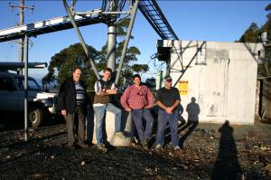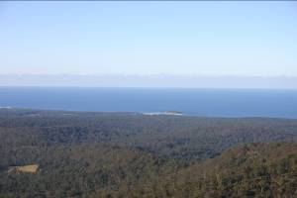
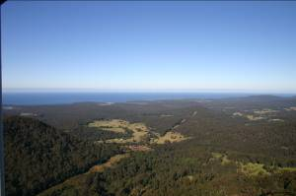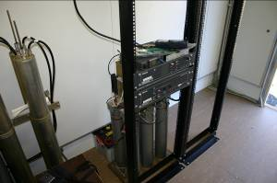
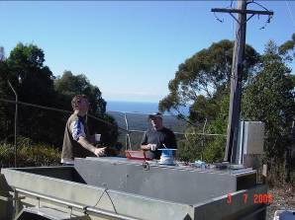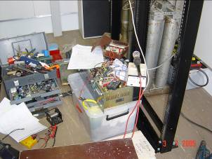

The Pictures

1 The work team
2 The view to towards the NE
3 The view south towards Bateman’s Bay
4 The IARS equipment in its new home
5 Planning and strategy development conference with coffee.
6 Rob repairing the DTMF de-coder, but, he was conferencing when the photo was taken, see 5.

Christmas in July

15th July, 2005

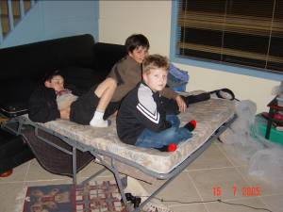
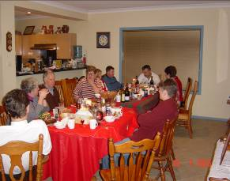

On the 15th July, the IARS celebrated Christmas in July at John and Maeva Bennett’s at Barrack Point.

It was attended by Rob McKnight, the Rewak family, the Davis Family, Ros and John Lawler, Peter and Leigh Reid, and the Desceso family.

The dinner was a great success with the adults celebrating with the traditional dinner and the
juniors had their own party with traditional children’s party food, DVD’s games and videos.

It was an evening of good food, good friends and excellent conversation.

Hopefully, this event will be on again next year as it not only raises valuable funds to assist the Club maintain it’s repeater sites, it is a chance for families to get together and have some fun sharing their hobby with others in a social atmosphere.

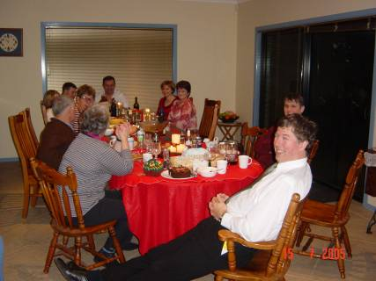
About the Airwaves.

1 The Coffee/Tea Night at the July meeting was a great success with members enjoying chocolate sponge, cheese cake, caramel mudcake and yummy homemade muffins made by Leigh Reid. Thanks to the donations of our members the Club raised $40.85 for our Club funds. Thanks must also go to Michele’s at Warilla Grove for donating the delicious cakes and to Leigh.

2 If you have any items you would like broadcast on Tuesday nights, please contact Geoff Howell either by phone on 42725134 or by email at vk2hic@nsw.chariot.net.au.

3 Over the past few months, many members have changed their email addresses, as emails sent by the secretary have comeback undeliverable. If you have changed your email address, could you please let the secretary know, so that our Member Registry is up to date.

4 Graeme (VK2QI)and Sue Cashion are proud new grandparents to a beautiful little girl, Latesha Elise Cashion. Congratulations to her parents Philip and Elise Cashion as well. I know Sue had been knitting some gorgeous little outfits for her new little girl.

5 After the AGM on Tuesday the 9th, it is Homebrew Night so bring in your latest project to inspire other members and show off your achievement.

6 Yours truly, cornered Jack Desceso at Christmas in July to secure for all our members special offers and a members discount on their purchases from his store Newteck in Keira Street Wollongong. Take him up on his offer to help with your homebrewing or repairs and modifications. His technical knowledge is a bonus for all, visit or phone through an order.

7 Many thanks to Barry Fittler, VK2DLI and Rod McCosker VK2DOT for their informative talks at the June and July meetings. I am sure members walked away with new knowledge and many questions answered.

Some Humour before we go

A mechanic was removing the cylinder head from the motor of a B.M.W. which belonged to a well known heart surgeon.
The surgeon came to see how his pride and joy was coming along.
The mechanic saw him come in and shouted across the garage,” Hey doc can I ask you a question?”
The surgeon said “Of course you can, he walked over to the mechanic who was working on his car.
The mechanic straightened up, wiped his hands on a rag, and said “So doc, I look at this engine, I open it’s heart, take the valves out, fix them and put them back, and when I finish it works just like new. So how come, I get such a small salary, and you get big dollars, when you and I are doing basically the same work?
The surgeon didn’t hesitate, he smiled and said, “Try doing it while the engine is running.”

Four MBA students were boozing till late night and didn't study for the test which was scheduled for the next day.
In the morning they thought of a plan. They made themselves look as dirty and weird as they could with grease and dirt. Then they went up to the dean and said that they had gone to a wedding last night and on their return the tyre of their car burst and they had to push the car all the way back and that they were in no condition to appear for the test.

The Dean was a just person so he said that you can have a retest after three days.
After 3 days they said they were ready. On the third day they appeared before the dean. The Dean said that as this was a special condition all four were required to be in separate rooms for the test.
They all agreed as they had prepared well in last three days. The test consisted of two questions with a total mark of 100.
Q1. Write down your Name.(2 marks)
Q2. What tyre burst? (98 Marks)

